EquiText:
A Helping Tool in the Elaboration of Collaborative Texts

Claudia Brandelero Rizzi
Programa de Pós-Graduação em Computação – Universidade Federal do Rio Grande do Sul
Universidade Estadual do Oeste do Paraná
Brazil
claudiab@inf.ufrgs.br

Cleuza Maria Maximino Carvalho Alonso
Universidade Federal de Santa Maria
Brazil
alonso@ccsh.ufsm.br

Elizângela Bastos Hassan
Universidade de Cruz Alta
Brazil
eliz@unicruz.tche.br

Liane Margarida Rockenbach Tarouco
Pós-Graduação em Informática na Educação – Universidade Federal do Rio Grande do Sul
Brazil
liane@penta.ufrgs.br

Louise Marguerite Jeanty de Seixas
Universidade Federal do Rio Grande do Sul
Brazil
seixas@farmacia.ufrgs.br

Abstract: Joining the national effort to develop a long-distance education in Brazil and based on the emphasis of the teaching/learning process bedded on the cooperation/collaboration , this work purposes to develop the EquiText tool, for the production of texts by a team, in a collaborative and asynchronous manner, and expressed through the written language. This tool, EquiText, is easy to use, free, portable and presents organization. Besides, it makes the text is being constructed available to everybody, at the same time. By doing so, all the team can make and see the alterations, and also can see where, when, why and by whom they had been made. Thus, each participant will be able to follow the " movement of the thought " of the other, in a really participant process of collaborative work.

Context and Motivation

In Brazil, there are support programs for the development of computer sciences in educational activities, as the National Program of Computer Science in the Education, which purposes to equip schools and to enable professors. Despite this fact, and also despite the efforts of the schools and the communities to make the knowledge available, there is still a lot of things to do in order to supply the lack of physical and human resources. Even though, the Brazilian educational community makes use of the features of computer science and in such a way recognizes the importance of these tools in education and learning.
So, it must be pointed out the creation, in 1996, of the first PhD course in Computer Science in Education, at the Federal University of Rio Grande do Sul (UFRGS), aiming to discuss and to suggest: the continued production of innovative knowledge in the computer science areas, education, psychology, and sociology, among others; to consolidate the Excellency Center in Computer Science in Education offered to UFRGS by the Science and Technology Ministry in the II National Plan of Computer Science (II PLANIN); to enable professionals of the educational area to interact with new technologies in its work environments; to support the UFRGS, in the Education Ministry long-distance education program, where several Brazilian Universities are acting in a joined task; to construct tools to support educational environments.
It can be observed in Brazil the necessity of changes in the education which will promote new abilities in the production and use of the knowledge in Computer Science in the Education. It is necessary to improve and to discover new ways of teaching and learning so that there can be a qualified educational system which can take care of the necessities and the goals of this new society in a properly manner. The possibilities of the new technologies of Computer Science must be used by the educational system to prepare the new citizen for a society model based on the new levels of the human evolution. (PGIE,1999)
Through the Law 9.394/96, the National Education Management and Bases Law (LDB)(MEC,1999), the Brazilian government points the route to be followed by the Education, by indicating some alternatives for the inclusion in the educational process of as much people as possible. So, long-distance education appears as an option for this because of the existing cultural and educational diversities in this huge country. In this way, by associating the long-distance teaching definition (according to the Decree nº 2.494 of 10 February 1998 (MEC, 1999)) to the self-learning method, it is possible to verify that learning can not be seen as an isolated activity. Therefore, it is in the dynamics of the long-distance education, which is carried out most of the times through the written language, that there will be found the motivating factor for acting in the interaction, extending the access to the knowledge, not in an isolated manner anymore, but propitiating the collaborative work.
The theoretical model for this project is based on Vygotsky’s social-interactionist theory which considers that the mankind accumulated knowledge can be accessed through the human interaction and also, that when man acquires this knowledge, he becomes the subject of the history, not its object anymore. Furthermore, it must be detached that the essential element of this interaction is the social collaboration mediated by instruments and signs, it means, by the language. The alterations originated in the man’s mind by the use of instruments and signs as external support are what allows him to mediate a stimulus which will represent him in other circumstances. This representation is materialized in language, that constitutes a major system of instrumental mediation. Thus, it is verified that the use of technologies, as a mediating element between the man and the social-cultural way, introduces substantial changes in its reality, mainly in education. So, new challenges are brought to the educators because it is up to them to construct innovative methodologies and instruments, which allow a productive work.
In our national context, educator Paulo Freire states that the discovery of the teaching possibility is analyzed through the historical social relation of learning. In Freire’s words, “...it was through the social learning that, historically, men and women discovered that it was possible to teach. It was so, through social learning that, along the times men and women had understand that it was possible - afterwards, necessary - to make up ways, paths, and methods to teach. Learning came before teaching or, in other words, teaching is dissolved in the really fused experience of learning”(Freire,1996,p.26). Still according to the named author, “...when it is produced, the new knowledge surpasses the another one which once was new and becomes old and is “exposed” to be surpassed by another one in the following days. Therefore it is so fundamental to know the existing knowledge as to know that we are available and qualified to produce the still nonexisting knowledge. Teaching, learning and searching, all are about two moments of the gnosiologic cycle: the first in which someone teaches and learns the already existing knowledge and the second in which someone produces the still nonexisting knowledge”(Freire,1996,p.31).
Freire still points the teaching/learning interrelation as the producing of the knowledge originated from the dialogical teacher/student relation or, according to his words “to bring the other one close to the movement of his thought”(Freire,1996,p.132).
This point is reinforced by (Jaffee,1999) with the idea of the active learning: the “to learn it by doing it” in long-distance activities, usually is materialized through texts, which are not simple transcriptions but rather the products of reflection, reorganization and concept reforms, in a complex process of discoveries. The importance of this question of own and collective elaboration, is also recognized by Pedro Demo (Demo,1996,p.24) who affirms “when a text is only read in a reproductively manner or likewise copied, the reasoning, the questioning, the thinking knowledge still does not appear. When it is interpreted, it is assumed that some kind of participation already exists, even if extremely incipient, because it occurs the seeking for the comprehension about the meanings. The comprehension about the meanings of a text implies to establish relations between text and meaning, to move manners to understand and to comprehend, to inquire alternative possibilities of understanding, to discern and to give significance, and so one. This dynamics advances, moreover, when it is about to know how to write or rewrite a text, changing from reader to author. When the own elaboration appears, the knowledge of how to think and how to learn becomes visible”. Once more, the concept “learn to learn” is seen not as isolated learning, but also as something that emerges from the interactions who are produced in the group activities, and more specifically, from the texts which have been elaborated by group as its work product.
The challenge of a written production in collaborative way requires to the participants, the emphasis and the will to do it, in a continuous process of displaying ideas, arguments and negotiations. This process requires a nimble dynamics, so that the spent effort can effectively be directed to the creative act itself and not to seek for ways to overcome the difficulties of the mechanical act of writing the material. In other words: when an interaction between communicating people occurs through the machine, the text under construction must be equally accessible to all, at the same time, to allow that all can make and see the alterations, where, when and by whom they had been made, and also, in some cases, why they were done. In this way, each one will be able to follow the " movement of the thought " of the other, and then, really participate in the process.
In this educational optics, the proponent team of the EquiText aimed to identify the difficulties showed by the course of Post Graduation in Computer Science in Educational Course (PGIE) students, who are attending the Tele Education course, through the deeply lived experiences in the distance elaboration of collaborative works. The absence of a tool that could satisfy the group necessities so as: to be easy to use, to be free, portable, to allow organization, purposed the construction and implementation of a helping tool in the elaboration of collaborative texts via Web in an asynchronous way, the EquiText.
According to the interdisciplinary philosophy of the PhD course in Computer Science in the Education, there was a searching for a partnership with students of the technical area in computer science in order to have an effective discussion about the pedagogical proposal and the implementation of EquiText.

Proposal of the EquiText

The Equitext is a tool used for production of cooperative/colaborative texts. This tool works with concept of paragraphs, to facilitate the visualization of the individual contributions, allowing the inclusion, alteration, new exclusion or paragraph proposal. It makes available, also, to the participants, one stack of previous versions, which makes the text accessible to all, making possible the visualization of the alterations, where, when and by whom they had been made, so that the previous contributions are not lost.
The Equitext must be installed in a local server, where the produced texts will be stored. A password distributed to the participants of a work group makes possible the use of the EquiText. This password will allow the unrestricted participation, including, modifying, excluding or considering new texts. The following screen shows a general vision of the original version of the EquiText, seen through browser Netscape.
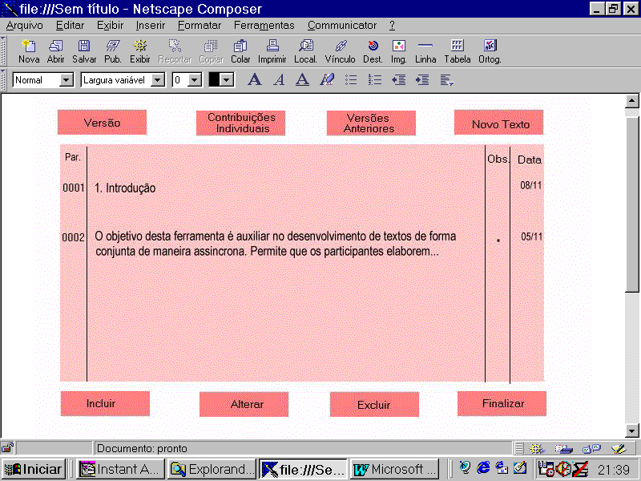

Figure 1: EquiText – Main screen

The EquiText works with the concept of "paragraphs". A title or even a line is seen as paragraphs. Such paragraphs are identified with a sequential number, initiating on number one. Equitext was developed in Perl language (Perl,1999). Following, the functions of each button shown above are described in a synthetic form.

- Versão: it identifies the name of the text and its current version, beyond other information concerning the involved work group, such as deadline, coordination (if it has), links and others;

- Contrubuições Individuais: it presents a stack of all the individual contributions to the text, as much for name as for date. In this stack, it has the identification of the participant’s name, the type of its contribution (inclusion, alteration, exclusion, new proposal) and the paragraph that was made. It is possible to see, if it has, comments on the contributions proposals;

- Versões Anteriores: it contains a stack of links, organized for date, of the previous versions of the text. To each of the participants’ contribution (inclusion, alteration or exclusion) is made a copy of the previous version, that is here made available;

- Novo Texto: it allows the participant initiates a new text. When he presses this button, he is requested to inform the name of the text and any other necessary information such as conclusion deadline, comments, etc. These notations are visible through the button "Versão".

- Incluir: it allows the participant to include paragraphs. When this button is pressed, the number of the paragraph to be included is requested. If, like in the example above, the participant desires to include a paragraph after the title " 1. Introduction ", it must inform number 2. This way, after the conclusion of the inclusion operation, the EquiText makes an arrangement of the following paragraphs, renumbering them, so that previous paragraph 2, becomes paragraph 3, and successively. It is possible to make notes for the inclusion proposal. In this in case that, it is attached an asterisk to the respective paragraph, signaling its existence. This alternative is also available for the activities of alteration and exclusion, presented as follow.
- Alterar: it allows that the participant modifies an existing paragraph. When this button is pressed, the number of the modified paragraph is requested. If this number exists, all the corresponding paragraph is copied for an properly form, allowing that the desired alterations are made. When the alteration is made, the submission option is allowed, which ups to date the text.

- Excluir: it allows that the participant excludes an existing paragraph. When this button is pressed, the number of the modified paragraph is requested. If this number exists, the corresponding paragraph is presented and it is requested the confirmation of the exclusion operation. Then the submission option is allowed. This action ups to date the text, eliminating the paragraph in question, rearranges the numerical sequence of the paragraphs and ups to date version of the text.

- Finalizar: it allows that any participant generates a list of the current situation of the text in form of page HTML. This task is made normally, but not necessarily, in the conclusion of the works. The goal of this task is to make possible the elaborated text be independent of the EquiText tool, being able to become a page HTML as another any one.

- The column " Obs. " means aditional comments. The paragraph that contains an asterisk in this column, indicates the existence of commentaries that become visible when pressed the button on the corresponding marking. The presented commentaries always refer to the last alteration proposal. However, it is possible to consult the previous commentaries by searching them in the "Versões Anteriores" of the text. These commentaries also permit that is established a quarrel on questions of the theme of which text is being elaborated, allowing to offer, to defend and to contest ideas, in a sharing construction.

- The column " Data " contains the date where the paragraph was offered or modified. The main goal of this column is stand by the reader in the verification of which parts of the text had been modified, and when this was made.

To use the EquiText, the school or interested organization can acquire a copy for installation for free on the site ftp://penta.ufrgs.br/pub/equitext, via download.

Final Considerations

The EquiText is used as a helping tool in the elaboration of cooperative/colaborative texts in long-distance courses, being its implementation occurred during the course of Fundamental and Techniques of Groupware. This version is in phase of test and evaluation.
It is important to say that the current version of the EquiText is not conclusive nor definitive. Since its initial conception it has suffered improvements and it is expected that during its use other contributions for its improvement can appear.
The results gotten until the moment, with the use of the EquiText are promising. The proponent team think to have reached its goals, which are the construction and availability of a tool with features of easiness of use, share, portability and organization. Moreover, the team recognizes that the efforts to try to be faithful to the theoretical and philosophical conceptions that had based the conception of the EquiText, had been preserved.

References

Demo, Pedro. (1996). Educar pela Pesquisa. Campinas, SP: Autores Associados.

Freire, Paulo. (1996). Pedagogia da Autonomia. São Paulo, SP: Paz e Terra.

Jaffee, David. (1999). Asynchronous Learning Networks Distance Learning Sociology. Disponível online em: http://www.newpaltz.edu/~jaffeed/esstsxx.htm: download em 17 de novembro de 1999

MEC (1999). Ministério da Educação. Disponível online em: http://www.mec.gov.br: download em 17 de novembro de 1999

Perl Mongers. (1999). Perl Mongers. Disponível online em: http://www.perl.org: download em 17 de novembro de 1999.

PGIE (1999). Pós Graduação em Informática na Educação. Disponível online em: Http://penta.ufrgs.br/pgie/homepgie.htm: download em 17 de novembro de 1999.

Vygotsky, L.S. (1993). Obras Escogidas V. II . Madrid. Visor.

